

**Clear**

**Reflections**

|  |  |  |
| --- | --- | --- |
| **Supervisor:** | *LÊ THANH NHÂN* | |
| **Semester:** | *01* | |
| **Batch No:** | *T1.2201.E0* | |
| **Group No:** | *04* | |
| **Order:** | **Full name** | **Roll No.** |
| *1.* | *Phạm Trung Nhân* | *Student1362614* |
| *2.* | *Trần Anh Tú* | *Student1359476* |
| *3.* | *Trần Cao Tiến Sỹ* | *Student1359463* |
| *4.* | *Trần Phạm Duy Thanh* | *Student1359464* |

***Month****: 04* ***Year****: 2022*



This is to certify that

|  |  |
| --- | --- |
| **Mr.** | **PHẠM TRUNG NHÂN** |
| **Mr.** | **TRẦN ANH TÚ** |
| **Mr.** | **TRẦN CAO TIẾN SỸ** |
| **Mr.** | **TRẦN PHẠM DUY THANH** |

Have successfully Designed & Developed

|  |  |  |
| --- | --- | --- |
|  |  |  |
| **CLEAR REFLECTIONS** | | |

Submitted by:

|  |
| --- |
| **Mr. LE THANH NHAN** |

Date Of Issue:

|  |  |
| --- | --- |
|  |  |

Authorized Signature:

|  |  |
| --- | --- |
|  |  |

|  |
| --- |
| CONTENT |

TABLE OF CONTENTS

CONTENT 2

ACKNOWLEDGE 1

SYNOPSIS 1

PROBLEM DEFINITION 1

Clear Reflections: 1

Requirement Specification: 1

Customer Requirements Specifications 3

User: 3

Webmaster: 4

Hardware / software requirement: 5

Architecture and design of the project 6

Site map 7

Screen shots 8

I. Homepage: 8

II. Products page 9

III. Contact Us page 10

Testing document 11

Final checklist 12

TASK SHEET 13

|  |
| --- |
| ACKNOWLEDGE |

As we understand that the eProject is a step-by-step learning environment that closely simulates the class-room and Lab based learning environment into actual implementation. It is a projectimplementation at your fingertips!! An electronic, live juncture on the machine that allows you to.

* Practice step by step i.e. laddered approach.
* Build a larger more robust application.
* Usage of certain utilities in applications designed by user.
* Single program to unified code leading to a complete application.
* Learn implementation of concepts in a phased manner.
* Enhance skills and add value.
* Work on real life projects.
* Give a real life scenario and help to create applications more complicated and useful.
* Mentoring through email support.

We would like to send a great thank to our professor and others student for the addorable supports during the time in project.

Beside serveral mistakes we had made in the project, we hope to have more oppotunities to widen our knownledge in web developing world.

We also thank you so much for your infomation and the “demo” project from India APTECH to help us get more reality experience in this project. Since we have gained more experience from this project, we will not stop learning any thing as much as we can to be more successful in the future.

Your Sincerely,

Team Group 04.

|  |
| --- |
| SYNOPSIS |

The Objective of this program we aim is to give a sample project to work on real life projects. These applications help us build a larger more robust application.

The objective is not only to teach us HTML/JavaScript but also to provide us with a real life scenario and help us create basic applications using the tools.

We can enhance our skills and value with the project.

This project is meant for students like us who have completed the module of HTML5. These programs should be done in the Lab sessions with assistance of the faculty if required.

The website is an online store specializing in the sale of interior mirrors. Customers can choose the type of mirror and material they want.

It is very essential for us that will have a clear understanding of the subject. We think we should go through the project and solve the assignments as per requirements given.

And get back ***eprojects@aptech.ac.in*** as the assigned schedule.

|  |
| --- |
| PROBLEM DEFINITION |

## Clear Reflections:

***Clear Reflections*** is an organization selling mirrors. They sell varieties of mirrors of different types suiting every requirement and into various sizes/shapes, starting from office to home and etc.

You are supposed to create a website for them with the below mentioned requirement specifications.

The website is to be developed for the Windows Platform using HTML5, JavaScript and Geolocation. The site should work well in all leading browsers including Chrome, IE, Firefox etc.

## Requirement Specification:

1. The homepage is the first thing visitors see when users come to our site, so it's essential that I will create an eye-catching design. I will use sections and put up images or logos in them for added personality!
2. The site must have a clear and straightforward navigation system so users can easily find what they need.
3. The site must have a clear and straightforward navigation system so users can easily find what they need.
4. The user can customize their search to only show them what they are looking for. For example, if someone wants a mirror that's just only put in the drawing/living room then he or she would be able click on this button and view all of those types without being flooded with other categories like "bedroom” etc.
5. The mirrors should be displayed on the web page along with a picture, but detailed features can easily downloaded or viewed by anyone who wants.
6. The sample categories can be:

* Drawing/Living room mirrors
* Bathroom mirrors
* Dressing mirrors
* Bedroom mirrors
* …user can add categories of their own choice too

1. There should also be categorization depending on material like:

* Wooden framed
* Acrylic bordered
* Metal bordered
* Decorative mirrors
* LED mirrors
* Bluetooth mirrors

1. We want to ensure that you can reach out easily when necessary. There should be a "Contact Us" page on our site with contact information displayed using GeoLocation API (eg: Google Maps) and an email address for people who click it send them messages from their local mail client so they're always in touch!

|  |  |  |  |  |  |  |  |  |  |  |  |  |  |  |  |
| --- | --- | --- | --- | --- | --- | --- | --- | --- | --- | --- | --- | --- | --- | --- | --- |
| |  | | --- | | Customer Requirements Specifications |  |  |  | | --- | --- | | User: | | |  | **Input:** | |  | * Click on the link bar to navigate to the “Homepage”, “Product” or “About us”. * Categorize the products according to the type or material. * Click “Download” buttons for downloading documents from website of Clear Reflections. * Feedback form will send us an email. | |  | **Process:** | |  | * Brings the user to “Homepage”, “Product” or “About us”. * Filter the products according to the type or material. * Take the details document when the user click “Download” buttons to give us to download. * Get the information from feedback form and exceptional processing. | |  | **Output:** | |  | * “Homepage”, “Product” or “About us” will appears. * Products are filted by the type or material. * Customer will receive a details document about one product they are interested. | |

|  |  |
| --- | --- |
| Webmaster: | |
|  | **Input:** |
|  | * Click on clickable link from menu. * Click to clickable links/images in “Products” or “Categories” * Click “Download” buttons for downloading documents from website of Clear Reflections. * Feedback form to send us an email. |
|  | **Process and Output:** |
|  | * Provide a website to display information about products categorizing product information according to furniture categories, type, size, material) and Origins. * The website should have soothing color with proper logo and images. * A main menu must have: Home, About us, Products and Shops. * A brief summary of individual products should be displayed on the Web Page along with the product but detailed Features should be stored in Individual Word documents which can be downloaded or viewed by the User who wishes to see the same. * If users wish to send us an email or look for our physical location, users should be able to do so in “Contact us” page. |

|  |  |  |
| --- | --- | --- |
| Hardware / software requirement: | | |
|  | **Software:** |
|  | * Notepad/HTML editor * Dreamweaver * IE 5.0/ Netscape 6.0 |
|  | **Hardware:** |
|  | * A minimum computer system that will help you access all the tools in the courses is a Pentium 166 or better * 64 Megabytes of RAM or better |

|  |
| --- |
| Architecture and design of the project |

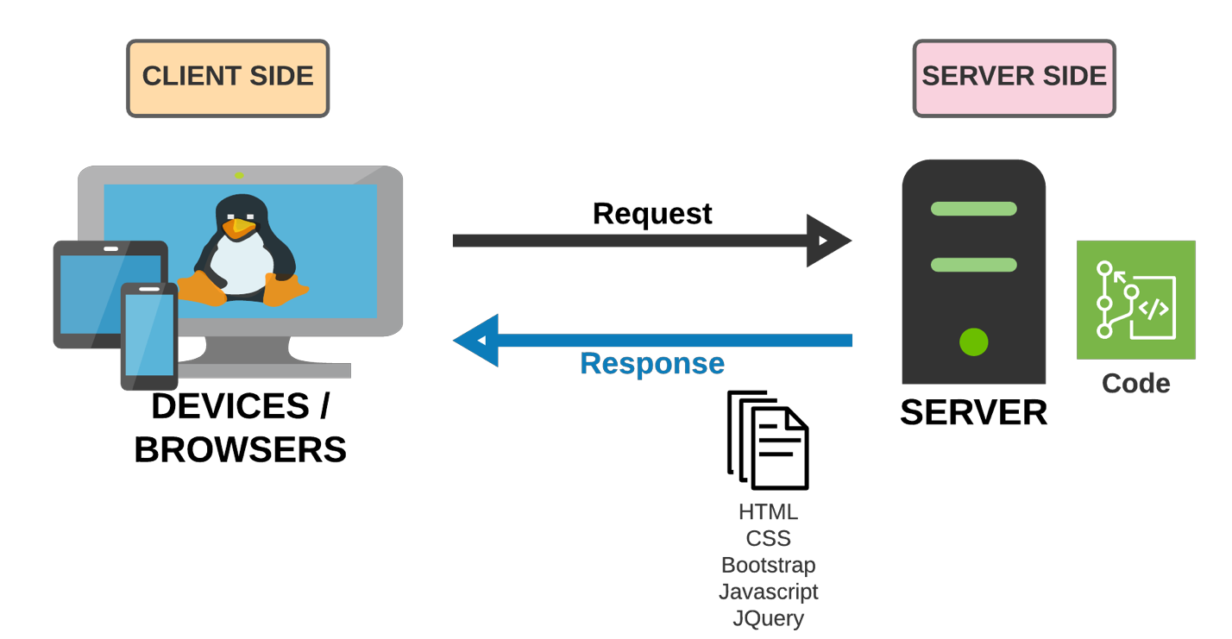

|  |
| --- |
| Site map |

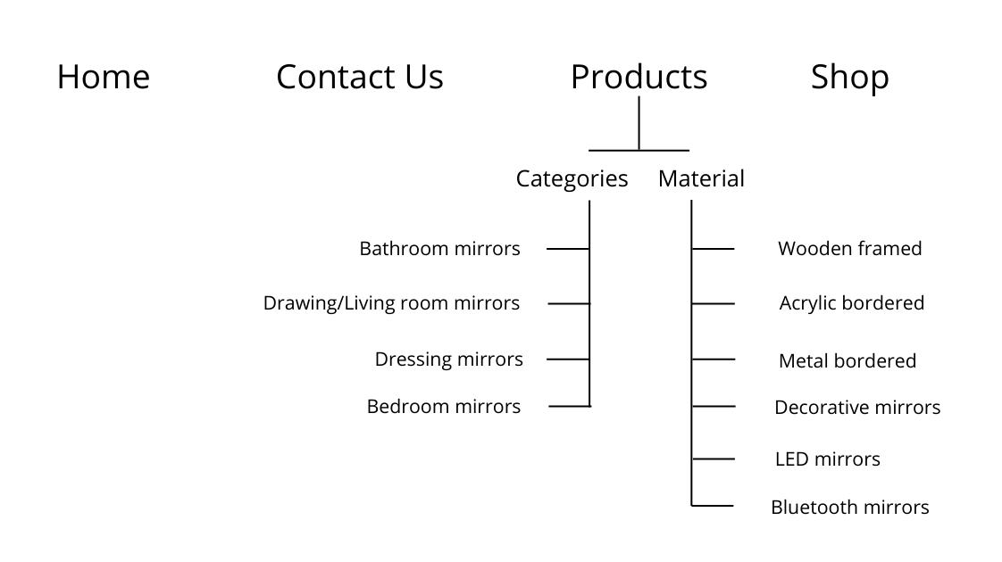

|  |
| --- |
| Screen shots |

## Homepage:

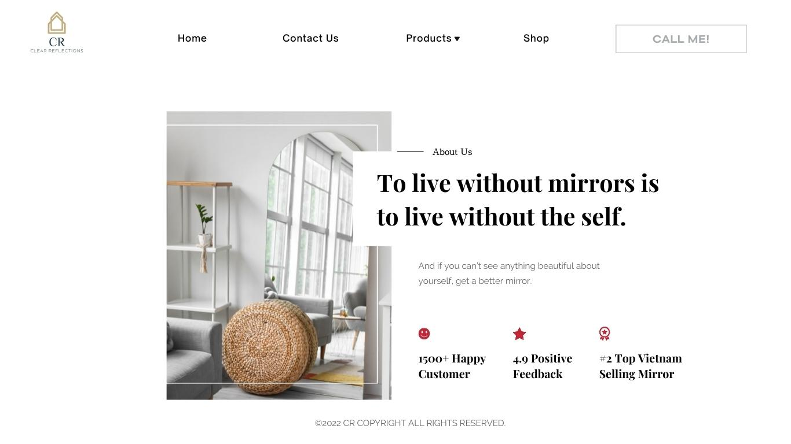

**Description** : We have a logo on the top left of the homepage. The navigation bar include: home, contact us, products and shop. The user can find all product by clicking on products button. “To live without mirrors is to live without the self” is our slogan.

**From** : The user can find all product by clicking on products button.

**To** : In the Products page, All the products can be categorized according to the categories /material of the mirrors.

## Products page

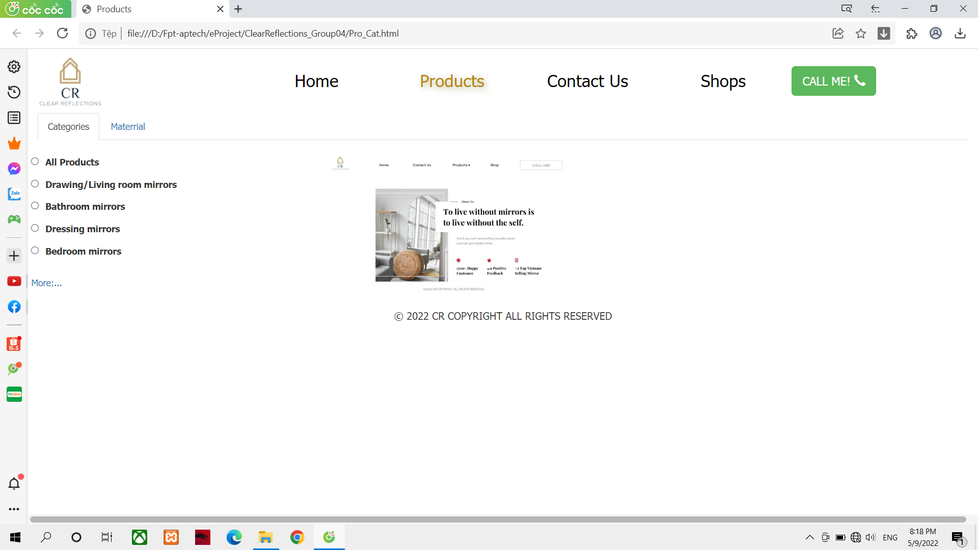

**Description** : The Product Page allow user to choice their type or material of the mirror

**From** : Users can click on Material or Categories to filter out the products they want

**To** : Product page matching user's filter request

## Contact Us page

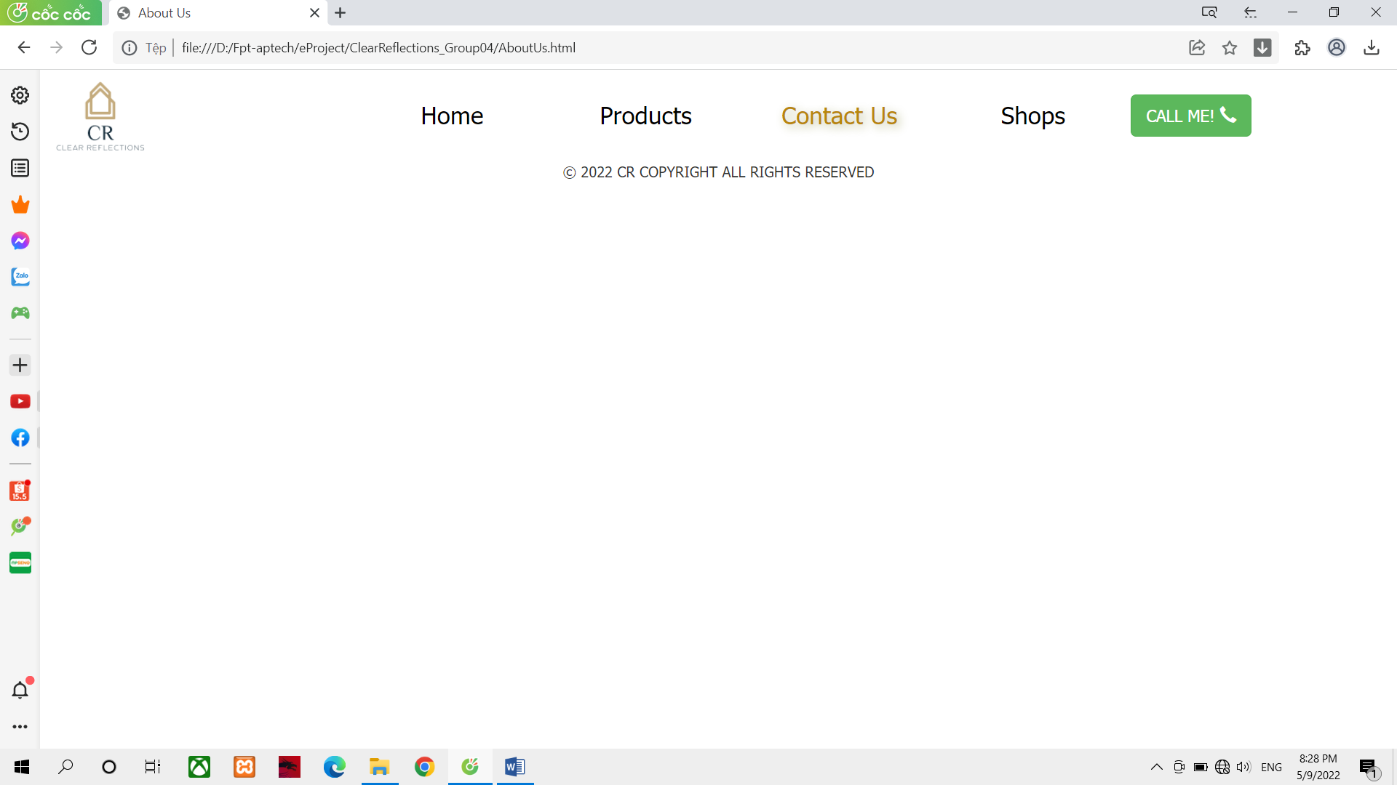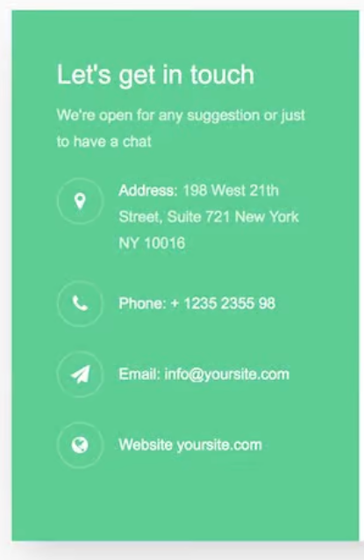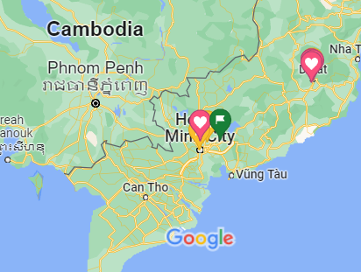

Geolocation map

Geolocation map

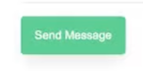

**Description** : The contact page contains all the company's contact information such as address, email, and phone number. In addition, it also contains a geolocation that allows Google maps to be displayed so that users can easily locate the store. In addition, a Send Message button for quick emailing to the store

**From** : Users can activate the google map application from a computer or mobile device to determine the itinerary and store location. In addition, if you have any questions, you can email the store with the Send Message button

**To** : Notification email has been sent to the store

|  |
| --- |
| Testing document |

|  |  |  |
| --- | --- | --- |
| **Sr.No** | **Features Tested** | **Remarks** |
| 1 | Homepages of retail sites are busy. They have a lot going on. |  |
| 2 | Once a user finds a product either through search or by browsing or by clicking on it from the homepage, the user will be taken to the product information page. |  |
| 3 | Since these are dynamic elements, the best way to test these parts of the application is to test the algorithm based on which these sections are populated. |  |
| 4 | Download button is clickable for each user |  |
| 5 | Links broken is not an option |  |

|  |
| --- |
| Final checklist |

|  |  |  |
| --- | --- | --- |
| **Sr.No** | **Aspected Tested** | **Suggestion/**  **Remarks** |
| 1 | Are all the users able to view the images and links? |  |
| 2 | Have all the views, modules and controllers been properly integrated and is the site function as a single page application? |  |
| 3 | Are the GUI content devoid of spelling mistakes? |  |
| 4 | Is the application user-friendly? |  |
| 5 | Is the Website launching correctly in all popular browsers? |  |
| 6 | Are all the forms validated with proper criteria? |  |
| 7 | Do all text links lead to the appropriate website? |  |
| 8 | Do all image links lead to the appropriate website? |  |
| 9 | Are all the images and links clearly visible on the page? |  |
| 10 | Does the Web page work properly in all the tested browsers? |  |
| 11 | Does the Web page take too long to be loaded fully? |  |
| 12 | Is the navigation sequences correct through all the Web pages on the site? |  |
| 13 | Is the JavaScript code working as expected in all click events? |  |

|  |
| --- |
| TASK SHEET |

|  |  |  |  |  |  |  |  |
| --- | --- | --- | --- | --- | --- | --- | --- |
| **No** | **Member** | **Contents** | **Page Name** | **Activity Plan** | **Date of Preparation of Activity Plan** | | |
| **Planed Start Date** | **Actual Start Date** | **Actual Days** | **Status** |
| 1 | Phạm Trung Nhân | Hompage | Hompage.html | 22-04-2022 | 02-05-2022 | 5 | OK |
| 2 | Categories | Categories.html | 22-04-2022 | 02-05-2022 | 5 | OK |
|  | | | | | | | |
| 1 | Trần Anh Tú | Register | Register.html | 22-04-2022 | 02-05-2022 | 5 | OK |
| 2 | Contact us | Contactus.html | 22-04-2022 | 02-05-2022 | 5 | OK |
|  | | | | | | | |
| 1 | Trần Cao Tiến Sỹ | Search | Search.html | 22-04-2022 | 02-05-2022 | 5 | OK |
| 2 | Geolocation | Geolocation.html | 22-04-2022 | 02-05-2022 | 5 | OK |
|  | | | | | | | |
| 1 | Trần Phạm Duy Thanh | Logo  Document | Logo.png | 22-04-2022 | 02-05-2022 | 5 | OK |
| 2 | Document | 22-04-2022 | 02-05-2022 | 5 | OK |